

Google Map Data System

**ISTM 6202 Team Project (Spring 2023)**

**Team 02**

Gu, Yijia

Mundiya, Christine Nyasha

Patil, Komal

Yuan, Mingze

**Table of Contents**

**Executive Summary 2**

**Section I: Business Problem 2**

1.1 Introduction for Google Map and Further Improvement 2

1.2 As-IS Business Process Map 4

1.3 Conceptual Database Design (As-IS ERD) 6

**Section II: IT-Based Solution Development 6**

2.1 Description of IT-based Solution 6

2.2 To-Be Business Process Map 7

2.3 Conceptual Database Design (To-Be ERD) 9

2.3.1 Business Rules 10

2.4 Business Function to Data Entity Matrix 12

2.5 Logical Database Design 13

**Section III: Database implementation 14**

3.1 Physical Database Design 14

3.2 Create Database 18

3.2.1 Insert Data 18

3.2.2 Queries 22

**References 27**

## *Executive Summary*

Google Maps is one of the most popular map systems in the world, with around 154.4 million users per month (Google, 2022). As a comprehensive global map system, Google Maps offers various features to users, such as 3D view, geographic location retrieval, navigation, as well as various types of routes for walking, driving, or cycling. Despite the fierce competition in the mapping system market, Google Maps maintains strong and stable competitiveness.

However, the real-time information updates of Google Maps have always been unstable and inaccurate. It not only reduces the overall user rating but also causes loss of active users. Regardless of how many other types of navigation software Google may launch in the future, the accuracy of information is always one of the most important factors in map software. We recommend that Google Maps provide customers with interactive panels to collect real-time feedback from customers, thereby improving the accuracy of real-time information of Google Maps.

In our proposal, we will outline the current business process map and ERD model of Google Maps, as well as our solution to this issue. We will design a model that can import real-time feedback information from users and provide an example database library.

## *Section I: Business Problem*

### 1.1 Introduction for Google Map and Further Improvement

Google Maps is a web-based mapping service developed by Google. It allows users to view maps, get directions, search for locations, and explore areas in 3D . It was first launched in 2005 and has since become one of the most widely used mapping services in the world. It provides detailed information about nearly every location on Earth. Besides, it includes real-time traffic updates and transit information (Google, 2022).

With the development of technology, an increasing number of users have raised their demand for navigation systems. This also indicates that people's demand for real-time traffic information has increased. However, by observing user reviews of Google Maps in the Apple Store and Android Store, we found that Google Maps' updates on real-time traffic conditions are far from meeting customer satisfaction. Here are some quoted real user reviews of Google Maps from the Apple Store (2023).

“Wrong estimate time.”

“Thank you for making me violate the paid bridge.”

“It gives me the one route with lanes closed.”

As Google Maps cannot collect enough real-time data, complaints from Google Maps users are increasing gradually. There is no doubt that negative reviews of Google Map navigation feature will have a significant negative impact on Google in the long term, including the following aspects:

Customer: According to user reviews of Google, it can be seen that many users have become extremely disappointed with Google Maps due to errors in real-time traffic information and have threatened to uninstall the application. Over time, Google Maps will face reputation risks, and its user loyalty and user stickiness will also decrease significantly. Google Maps will become uncompetitive among similar competitors.

Employees: Google's customer service will need to deal with more customer complaints and spend more time on customer service. Google engineers will also work longer hours to debug the system, making it better equipped to handle real-time data and meet user demands. Google may face increased hiring costs.

Business Revenue: Customer disapproval of the Google Maps system will lower Google's sales revenue. At the same time, the reputational impact on Google caused by customers may, in the long run, reduce Google's market share, resulting in a decline in stock prices. Google's revenue will face challenges in various dimensions.

We believe that it is urgent for Google to improve its database for Google Maps. Google needs a more sophisticated real-time data updating system to meet their customers’ needs. Google Maps needs to generate more accurate real-time traffic feedback. In our cases, the main reason why Google's real-time data cannot be updated in a timely manner is that Google's data sources are limited to satellite data and GPS navigation. Google does not have a way to receive real-time feedback data from users. Google needs to collect user feedback on road conditions in real time, mainly including: traffic jams, accidents, police, and road construction. After collecting a certain number of user feedback and confirmation notes in the same time period, the application should feed the information back to other users who are using the map in real time. This measure can improve the real-time monitoring performance of the Google Maps database, bring convenience to users, and enhance user recognition and loyalty.

### 1.2 As-IS Business Process Map

When users begin to use the navigation feature on Google Maps, they usually start by entering a destination. The Google system's database detects the precise location of the destination and processes the data through the Google Maps backend system to recommend the optimal route to the user. Google Maps can monitor real-time traffic conditions on various roads via satellite, indicating the estimated time to reach the destination through different routes, and allowing users to choose their preferred navigation path. During navigation, if users require additional guidance, they can enter the destination again in the search bar on Google Maps to obtain more information. After the navigation ends, Google Maps will display a feedback form to collect user feedback.

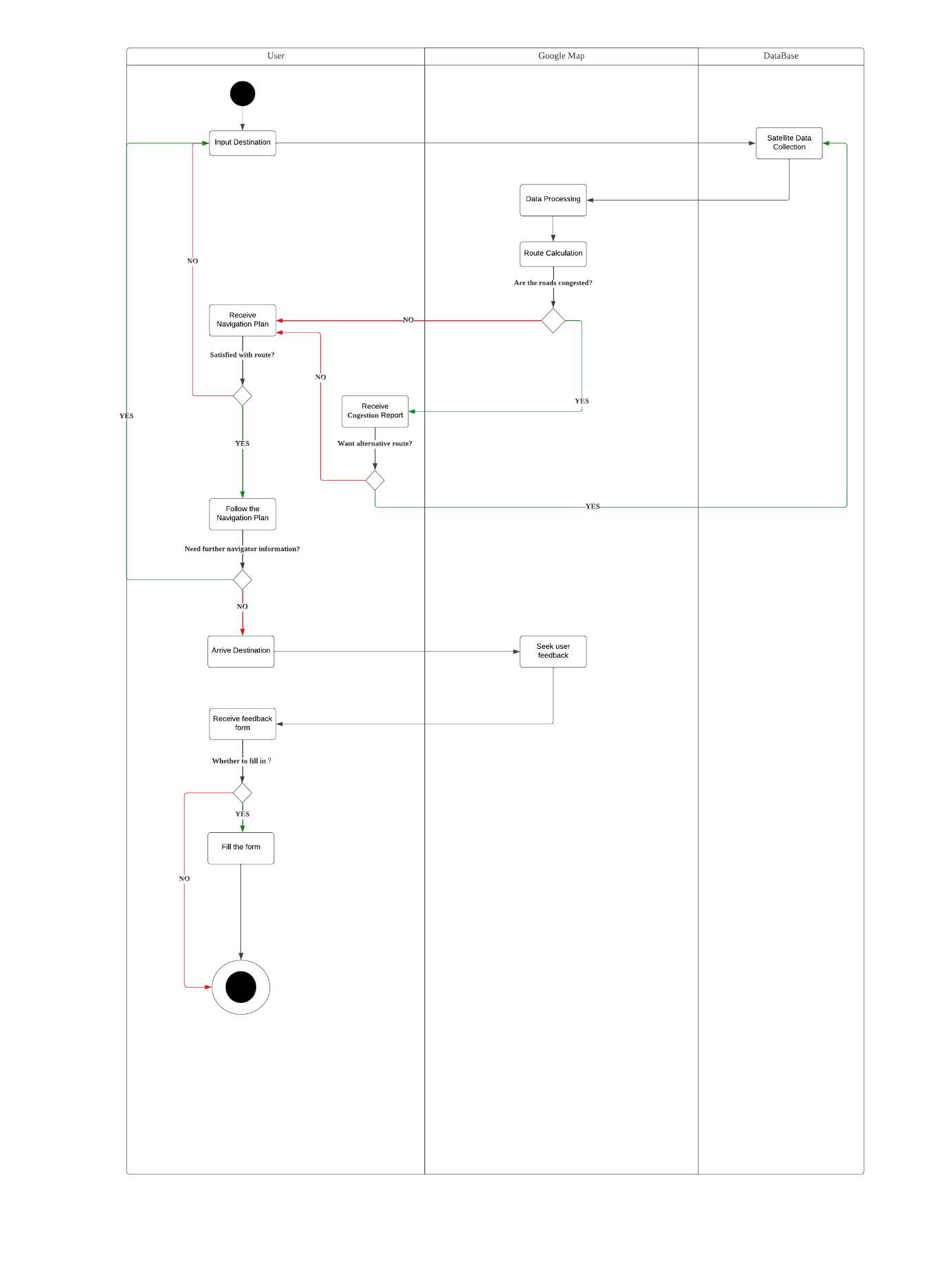

**Figure 1. As-Is Business Process Map for Google Map**

### 1.3 Conceptual Database Design (As-IS ERD)

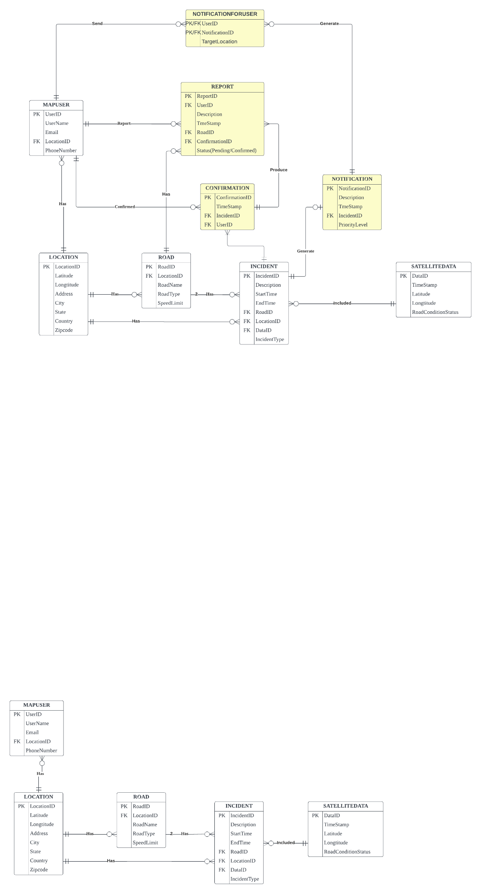

**Figure 2. As-Is ERD for Google Map**

## *Section II: IT-Based Solution Development*

### 2.1 Description of IT-based Solution

Our team is designing a web-based system in which users can report real-time road information to Google Maps. This system will enable users to report various types of incidents such as police, traffic jam, roadwork and accidents. The measure can help other users make informed decisions to avoid congestion about their travel routes.

The new system will have a user-friendly interface to facilitate the submission of reports by users. Users can select the type of incident they want to report and provide additional details if they want to (e.g. location, severity, time of occurrence). Once a case is reported, Google Maps will generate confirmation messages and send them to other users who will pass through the area in the next 5 minutes. The message will ask these users to help verify the accuracy of the reports. It looks like a pop-up window with the button “Yes” and “No”, so it is easy to click even while driving. After collecting a certain amount of confirmation, google map considers the information as "true" and starts the next step of data analysis.

The data collected from the users' reports will be processed and analysed using machine learning algorithms to identify the most critical incidents based on their emergency degree. The system will prioritise incidents based on the level of urgency, ensuring that the most important and critical information is displayed to users first.

Once the data has been analysed, the system will generate real-time alerts to notify users of incidents in their area. These alerts will be displayed on Google Maps for users to see the location and severity of the incident. Therefore, users with the notification can adjust their travel plans accordingly.

Overall, this IT-based solution will provide an effective way for users to report real-time road information. We believe it will improve travel safety and reduce road congestion at the same time.

### 2.2 To-Be Business Process Map

In the updated business process map, Google Maps provides users with an interactive panel to report real-time traffic conditions while driving. The report includes traffic congestion, accidents, police, and road construction. The data reported by users is stored in a database, which provides great convenience for Google Maps users. When Google Maps users start searching for a destination and receive navigation recommendations from Google, they can also receive reports of specific events occurring along their route. Compared to only collecting satellite data on road congestion in the past, the customer-reported database can provide users with more detailed and accurate real-time traffic reports. Users can know the traffic congestion, accidents, police, and road construction situations along their selected route, which also helps Google Maps navigation to more accurately estimate arrival time.

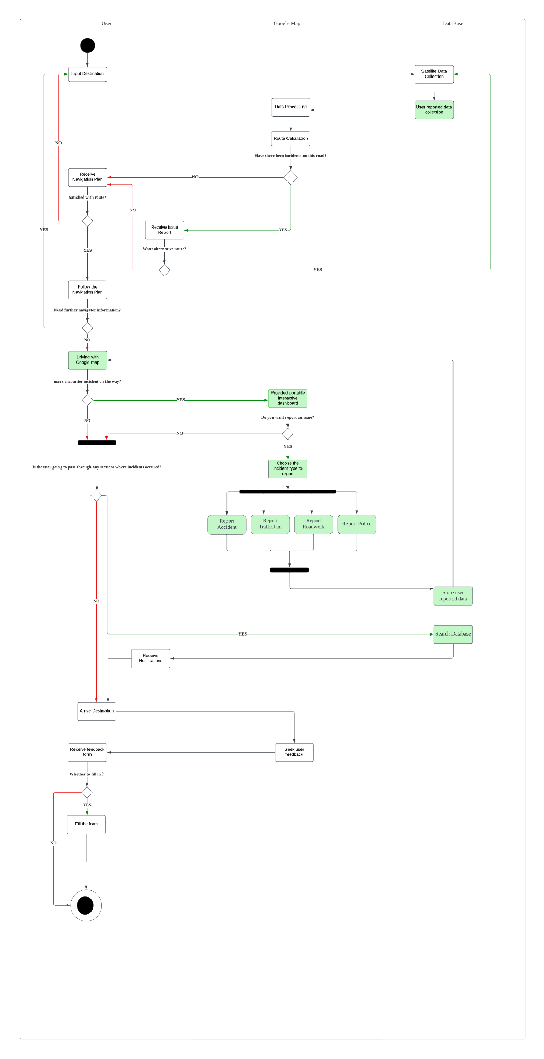

**Figure 3. To-Be Business Process Map for Google Map**

### 2.3 Conceptual Database Design (To-Be ERD)

In order to incorporate a new IT-based solution and business processes into the real-time monitoring navigation system of Google Maps, the database needs to be updated and expanded to include the necessary entities for the system to function properly. The new system will meet the information requirements of the 5C's in the following ways:

**Capture:** This involves capturing real-time data on road conditions, including traffic jams, accidents, police presence, and road construction. The data mainly comes from users. No matter if they are driving, walking, taking the bus or cycling, they will always have a chance to report road conditions they met. To achieve this, we will introduce a new report system that allows users to provide information by simple clicks on the screen, which will be captured and stored in the database.

**Convey:** Once real-time data is captured, it needs to be conveyed in real-time to the GPS database to store. It will be also conveyed to other users for information accuracy confirmation. This process will be achieved by implementing a standardised process for handling confirmed user reports, ensuring that the system communicates accurate and valid reports.

**Create:** With the help of a new real-time data system, we can create more accurate and detailed maps to help users easily navigate the road. Meanwhile, they will receive fewer false information and untimely information. This will improve user experience and increase user loyalty.

**Cradle:** All of the real-time data we collected needs to be cradled or protected to ensure its integrity and prevent it from loss. We plan to improve the data cradle by implementing robust data security protocols. Besides, we will also make sure that the database is regularly backed up.

**Communicate:** Finally, we need to let the new system users know the benefit to encourage them to use and contribute to the optimization of Google Maps. Our system will give positive feedback to users who submit useful reports. Additionally, we will promote the benefits of the new system in terms of improved navigation and user experience.

#### 2.3.1 Business Rules

A MapUser can submit 0 or multiple reports, but Report could be only submitted by 1 user.

A MapUser can confirm 0 or multiple confirmations, but Confirmation can be only submitted by 1 user.

A Notification can be sent to 0 or multiple MapUser’s, and MapUser can have 0 or multiple notifications.

An Incident can receive 0 or multiple confirmations, but a Confirmation should only commit to one incident.

An Incident can trigger 0 or 1 notification, and one Notification should only be triggered by one incident.

An incident has four subtypes that can overlap, including traffic jams, accidents, police, and road construction.

A Location can have 1 or multiple roads, but one Road only has one location.

A Location can have 0 or multiple users, but one User only has one location.

A Road can have 0 or multiple incidents, and one Incident has only one road.

One or multiple SatelliteData can report 0 or multiple incidents, and one Incident can have one or more satellites data.

A Confirmation can have multiple reports, and one report has one confirmation.

Confirmation can be associated with only one Mapuser, while a Mapuser can have multiple Confirmations associated with it.

A Notification can have multiple notificationforuser, but one notificationforuser can have only one notification.

Notification can only report one Incident, while an Incident can have zero or at most one Notification associated with it.

Report can be associated with only one Mapuser, while a Mapuser can have multiple Reports associated with them

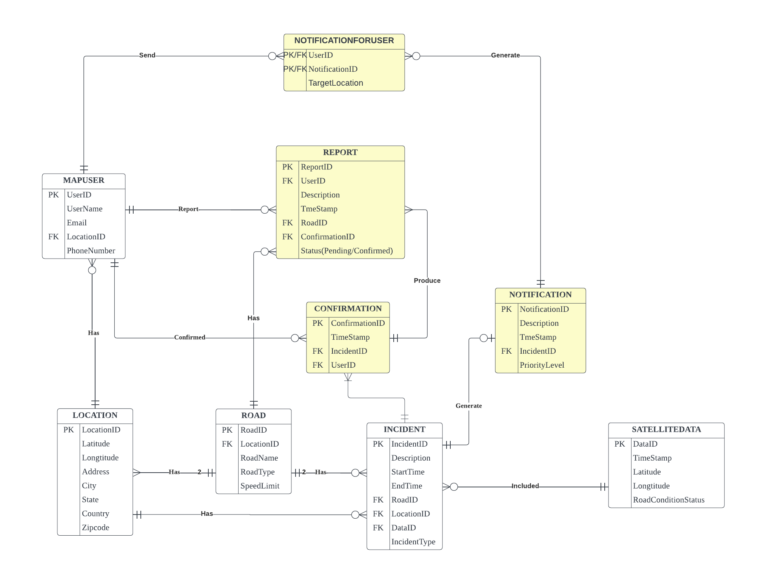

**Figure 4. To-Be ERD for Google Map**

### 2.4 Business Function to Data Entity Matrix

The below matrix demonstrates how data entities are associated with business functions that are in the new Google map systems:

| **Business Function/Data Entities** | **User Profile** | **User History** | **Location** | **Place Data** | **Traffic Data** | **Transit Data** | **Map Data** | **Road Incident** | **Satellite Imagery** |
| --- | --- | --- | --- | --- | --- | --- | --- | --- | --- |
| **Maps & Navigation** | X | X | X | X |  |  | X | X | X |
| **Traffic & Routing** | X | X | X | X | X | X | X | X | X |
| **Search & Discovery** | X | X | X | X |  |  | X |  | X |
| **Advertising** | X |  | X | X | X |  | X |  |  |
| **Analytics & Insights** |  |  | X | X | X | X | X | X | X |
| **Business Operations** |  |  | X | X | X | X | X | X | X |
| **Customer Support** |  | X | X | X |  |  | X |  |  |
| **Partnership Management** | X | X | X | X | X | X | X |  | X |

**Figure 5. Business Function for Google Map**

### 2.5 Logical Database Design

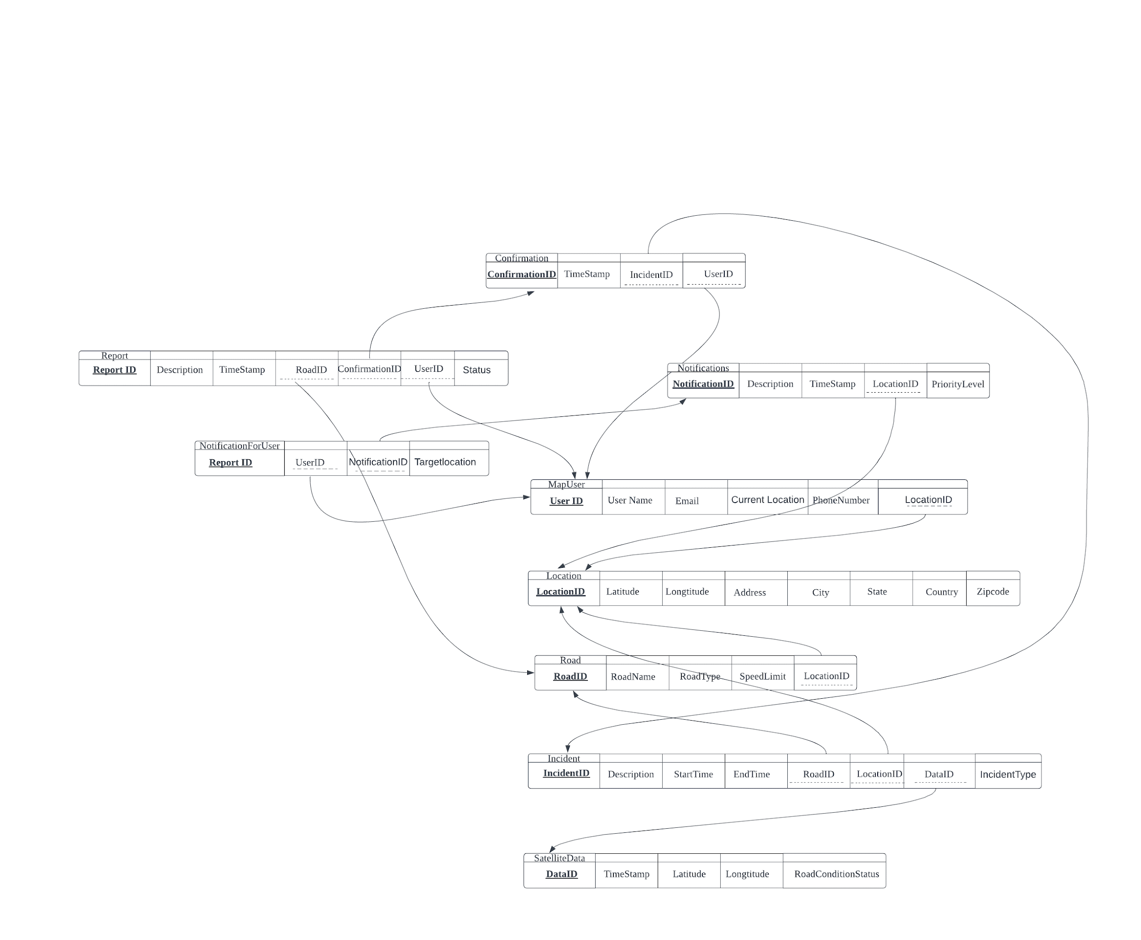

**Figure 6. 3NF Logical Database Design for Google Map**

## 

## *Section III: Database implementation*

### 3.1 Physical Database Design

create database GoogleMap_Team2;

create table location(

LocationID Int(11) not null,

Latitude float not null,

Longtitude float not null,

Address varchar(100) not null,

City varchar(20) not null,

State varchar(20) not null,

Country varchar(20) not null,

Zipcode int(6) not null,

constraint location_PK primary key(LocationID));

create table road(

RoadID Int(11) not null,

LocationID Int(11) not null,

RoadName varchar(100) not null,

RoadType enum('Freeways','Highways','Arterial','Collector','Local','Pedestrian','Private') not null,

SpeedLimit int(6) not null,

constraint road_PK primary key(RoadID),

constraint road_FK FOREIGN KEY (LocationID) REFERENCES location(LocationID)) ;

create table SATELLITEDATA(

DataID Int(11) not null,

TimeStamp Timestamp not null,

Latitude float not null,

Longtitude float not null,

RoadConditionStatus varchar(100),

constraint SATELLITEDATA_PK primary key(DataID)) ;

create table INCIDENT(

IncidentID Int(11) not null,

DataID Int(11) not null,

RoadID Int(11) not null,

LocationID Int(11) not null,

StartTime Timestamp not null,

EndTime Timestamp null,

IncidentType enum('Fire','Construction','Accident','Block','Police','Weather') not null,

CONSTRAINT INCIDENT_PK primary key(IncidentID),

CONSTRAINT INCIDENT_FK1 FOREIGN KEY (DataID) REFERENCES satellitedata(DataID),

CONSTRAINT INCIDENT_FK2 FOREIGN KEY (RoadID) REFERENCES road(RoadID),

CONSTRAINT INCIDENT_FK3 FOREIGN KEY (LocationID) REFERENCES location(LocationID));

create table NOTIFICATION(

NotificationID Int(11) not null,

TimeStamp Timestamp not null,

IncidentID Int(11) not null,

Description varchar(100),

PriorityLevel varchar(5),

constraint NOTIFICATION_PK primary key(NotificationID),

CONSTRAINT NOTIFICATION_FK FOREIGN KEY (IncidentID) REFERENCES INCIDENT(IncidentID));

create table MapUSER(

UserID Int(11) not null,

CurrentLocationID Int(11) not null,

Email varchar(10),

UserName varchar(10),

PhoneNumber varchar(15),

constraint MapUSER_PK primary key(UserID),

CONSTRAINT MapUSER_FK FOREIGN KEY (CurrentLocationID) REFERENCES LOCATION(LocationID));

create table NOTIFICATIONFORUSER(

UserID Int(11) not null,

NotificationID Int(11) not null,

TargetLocation varchar(100),

constraint NOTIFICATIONFORUSER_PK primary key(UserID,NotificationID),

CONSTRAINT NOTIFICATIONFORUSER_FK1 FOREIGN KEY (UserID) REFERENCES MAPUSER(UserID),

CONSTRAINT NOTIFICATIONFORUSER_FK2 FOREIGN KEY (NotificationID) REFERENCES NOTIFICATION(NotificationID));

create table CONFIRMATION(

UserID Int(11) not null,

ConfirmationID Int(11) not null,

IncidentID Int(11) not null,

Timestamp Timestamp,

constraint CONFIRMATION_PK primary key(ConfirmationID),

CONSTRAINT CONFIRMATION_FK1 FOREIGN KEY (UserID) REFERENCES MAPUSER(UserID),

CONSTRAINT CONFIRMATION_FK2 FOREIGN KEY (IncidentID) REFERENCES INCIDENT(IncidentID));

create table REPORT(

UserID Int(11) not null,

ReportID Int(11) not null,

RoadID Int(11) not null,

ConfirmationID Int(11) not null,

Timestamp Timestamp,

Description varchar(200),

ReportStatus enum('Pending','Confirmed'),

constraint REPORT_PK primary key(ReportID),

CONSTRAINT REPORT_FK1 FOREIGN KEY (UserID) REFERENCES MAPUSER(UserID),

CONSTRAINT REPORT_FK2 FOREIGN KEY (RoadID) REFERENCES road(RoadID),

CONSTRAINT REPORT_FK3 FOREIGN KEY (ConfirmationID) REFERENCES confirmation(IncidentID));

### 

### 3.2 Create Database

#### 3.2.1 Insert Data

**Satellitedata**

Insert Into SATELLITEDATA Values (1,'2023-04-20 15:15:30',38.913611,78.114222,'Normal');

Insert Into SATELLITEDATA Values (2,'2023-04-20 15:15:30',39.113611,76.015142,'Traffic Jam');

Insert Into SATELLITEDATA Values (3,'2023-04-21 15:15:30',40.978911,77.011922,'Block');

Insert Into SATELLITEDATA Values (4,'2023-04-22 15:15:30',38.913123,78.013219,'Normal');

Insert Into SATELLITEDATA Values (5,'2023-04-23 15:15:30',39.117811,77.045810,'Normal');

Insert Into SATELLITEDATA Values (6,'2023-04-24 15:15:30',39.961145,78.013814,'Incident');

Insert Into SATELLITEDATA Values (7,'2023-04-25 15:15:30',40.911811,79.013810,'Traffic Jam');

Insert Into SATELLITEDATA Values (8,'2023-05-23 15:15:30',41.945811,80.013810,'Incident');

Insert Into SATELLITEDATA Values (9,'2023-06-23 15:15:30',42.914811,76.013810,'Normal');

Insert Into SATELLITEDATA Values (10,'2023-07-23 15:15:30',43.967811,77.114514,'Block');

**Location**

Insert Into LOCATION Values (1,39.967811,77.013810,'540 Independence Ave SW, Washington, DC 20024','Washington DC','State of Washington','US',22201);

Insert Into LOCATION Values (2,39.113611,76.015142,'400 Maryland Ave SW, Washington, DC 20202','Washington DC','State of Washington','US',22202);

Insert Into LOCATION Values (3,40.978911,77.011922,'330 Independence Ave SW, Washington, DC 20237','Washington DC','State of Washington','US',22203);

Insert Into LOCATION Values (4,38.913123,78.013219,'550 C St SW, Washington, DC 20024','Washington DC','State of Washington','US',22204);

Insert Into LOCATION Values (5,39.967811,77.013810,'400 C St SW, Washington, DC 20024','Washington DC','State of Washington','US',22205);

Insert Into LOCATION Values (6,39.961145,78.013814,'541 Independence Ave SW, Washington, DC 20024','Washington DC','State of Washington','US',22206);

Insert Into LOCATION Values (7,40.911811,79.013810,'401 Maryland Ave SW, Washington, DC 20202','Washington DC','State of Washington','US',22207);

Insert Into LOCATION Values (8,41.945811,80.013810,'331 Independence Ave SW, Washington, DC 20237','Washington DC','State of Washington','US',22208);

Insert Into LOCATION Values (9,42.914811,76.013810,'551 C St SW, Washington, DC 20024','Washington DC','State of Washington','US',22209);

Insert Into LOCATION Values (10,43.967811,77.114514,'410 C St SW, Washington, DC 20024','Washington DC','State of Washington','US',22210);

**Road**

Insert Into ROAD Values (1,1,'C St SW','Freeways',50);

Insert Into ROAD Values (2,2,'E St SW','Highways',60);

Insert Into ROAD Values (3,3,'G St SW','Arterial',70);

Insert Into ROAD Values (4,4,'I St SW','Pedestrian',50);

Insert Into ROAD Values (5,5,'K St SW','Private',40);

Insert Into ROAD Values (6,6,'A St SW','Freeways',60);

Insert Into ROAD Values (7,7,'B St SW','Highways',60);

Insert Into ROAD Values (8,8,'D St SW','Arterial',65);

Insert Into ROAD Values (9,9,'Z St SW','Pedestrian',55);

Insert Into ROAD Values (10,10,'Y St SW','Private',45);

**Mapuser**

Insert Into MAPUSER Values (1,1,'a@g.com','Mr. A','+12675302407');

Insert Into MAPUSER Values (2,2,'b@g.com','Mr. B','+12024012000');

Insert Into MAPUSER Values (3,3,'c@g.com','Mr. C','+12022034000');

Insert Into MAPUSER Values (4,4,'d@g.com','Mr. D','+12024794000');

Insert Into MAPUSER Values (5,5,'e@g.com','Mr. E','+12024840803');

Insert Into MAPUSER Values (6,6,'f@g.com','Mr. F','+12675301107');

Insert Into MAPUSER Values (7,7,'g@g.com','Mr. G','+12024042000');

Insert Into MAPUSER Values (8,8,'h@g.com','Mr. H','+12022054000');

Insert Into MAPUSER Values (9,9,'i@g.com','Mr. I','+12024791000');

Insert Into MAPUSER Values (10,10,'j@g.com','Mr. J','+12024441903');

**Incident**

Insert Into INCIDENT Values (1,10,1,1,'2023-01-20 11:15:30','2023-04-21 15:25:30','Accident');

Insert Into INCIDENT Values (2,9,2,2,'2023-01-20 15:15:30','2023-04-21 17:15:30','Block');

Insert Into INCIDENT Values (3,8,3,3,'2023-03-20 15:15:30','2023-03-21 15:15:30','Block');

Insert Into INCIDENT Values (4,7,4,4,'2023-04-22 15:15:30','2023-04-22 16:15:30','Construction');

Insert Into INCIDENT Values (5,6,5,5,'2023-04-25 15:15:30','2023-04-25 15:45:30','Fire');

Insert Into INCIDENT Values (6,5,1,1,'2023-01-20 11:15:11','2023-04-21 15:25:30','Accident');

Insert Into INCIDENT Values (7,4,1,1,'2023-01-20 15:15:45','2023-04-21 17:15:30','Block');

Insert Into INCIDENT Values (8,3,1,1,'2023-03-20 15:15:14','2023-03-21 15:15:30','Block');

Insert Into INCIDENT Values (9,2,4,4,'2023-04-22 19:15:30','2023-04-22 19:25:30','Construction');

Insert Into INCIDENT Values (10,1,5,5,'2023-04-25 19:18:30','2023-04-25 19:45:30','Fire');

**Confirmation**

Insert Into CONFIRMATION Values (1,1,1,'2023-01-20 11:15:30');

Insert Into CONFIRMATION Values (1,2,2,'2023-01-20 15:15:30');

Insert Into CONFIRMATION Values (1,3,3,'2023-03-20 15:15:30');

Insert Into CONFIRMATION Values (2,4,4,'2023-04-22 15:15:30');

Insert Into CONFIRMATION Values (3,5,5,'2023-04-25 15:15:30');

Insert Into CONFIRMATION Values (1,6,6,'2023-05-20 11:15:30');

Insert Into CONFIRMATION Values (1,7,7,'2023-06-20 15:15:30');

Insert Into CONFIRMATION Values (1,8,8,'2023-07-20 15:15:30');

Insert Into CONFIRMATION Values (2,9,9,'2023-08-22 15:15:30');

Insert Into CONFIRMATION Values (3,10,10,'2023-09-25 15:15:30');

**Report**

Insert Into REPORT Values (1,1,1,1,'2023-01-20 11:15:40','Accident happen','Pending');

Insert Into REPORT Values (1,2,2,2,'2023-01-20 15:15:40','Block in this street','Confirmed');

Insert Into REPORT Values (1,3,3,3,'2023-03-20 15:15:40','We could not pass','Pending');

Insert Into REPORT Values (2,4,4,4,'2023-04-22 15:15:40','Seems some construction','Confirmed');

Insert Into REPORT Values (3,5,5,5,'2023-04-25 15:15:40','It has fire, dangerous','Pending');

Insert Into REPORT Values (1,6,6,6,'2023-05-20 11:15:40','Accident happen,no one hurt, but need more time','Pending');

Insert Into REPORT Values (5,7,7,7,'2023-06-20 15:15:40','Block in this street','Confirmed');

Insert Into REPORT Values (6,8,8,8,'2023-07-20 15:15:40','Event, could not pass','Pending');

Insert Into REPORT Values (7,9,9,9,'2023-08-22 15:15:40','Seems holding some event','Confirmed');

Insert Into REPORT Values (8,10,10,10,'2023-09-25 15:15:40','Many car, traffic jam','Pending');

**Notification**

Insert Into NOTIFICATION Values (1,'2023-01-20 11:17:40',1,'Accident happen 3km away from your position, please be careful!',73);

Insert Into NOTIFICATION Values (2,'2023-01-20 15:17:40',1,'There is block 2km from your position, please pay attention to notice.',40);

Insert Into NOTIFICATION Values (3,'2023-03-20 15:18:40',1,'There is block 3.5km from your position, please pay attention to notice.',50);

Insert Into NOTIFICATION Values (4,'2023-04-22 15:18:40',1,'There is constructed road 2km from your position. please pay attention to notice',37);

Insert Into NOTIFICATION Values (5,'2023-04-25 15:18:40',1,'Fire happend 6km from your position, please consider change path.',89);

Insert Into NOTIFICATION Values (6,'2023-02-20 11:17:40',1,'Accident happen 3km away from your position, please be careful!',72);

Insert Into NOTIFICATION Values (7,'2023-03-20 15:17:40',1,'There is block 2km from your position, please pay attention to notice.',39);

Insert Into NOTIFICATION Values (8,'2023-05-20 15:18:40',1,'There is block 3.5km from your position, please pay attention to notice.',59);

Insert Into NOTIFICATION Values (9,'2023-07-22 15:18:40',1,'There is constructed road 2km from your position. please pay attention to notice',30);

Insert Into NOTIFICATION Values (10,'2023-08-25 15:18:40',1,'Fire happend 6km from your position, please consider change path.',90);

**NotificationForUser**

Insert Into NOTIFICATIONFORUSER Values (4,1,'C St SW Near around');

Insert Into NOTIFICATIONFORUSER Values (5,2,'E St SW Near around');

Insert Into NOTIFICATIONFORUSER Values (5,3,'G St SW Near around');

Insert Into NOTIFICATIONFORUSER Values (2,4,'I St SW Near around');

Insert Into NOTIFICATIONFORUSER Values (3,5,'K St SW Near around');

Insert Into NOTIFICATIONFORUSER Values (3,6,'A St SW Near around');

Insert Into NOTIFICATIONFORUSER Values (3,7,'B St SW Near around');

Insert Into NOTIFICATIONFORUSER Values (8,8,'D St SW Near around');

Insert Into NOTIFICATIONFORUSER Values (9,9,'G St SW Near around');

Insert Into NOTIFICATIONFORUSER Values (3,10,'H St SW Near around');

#### 3.2.2 Queries

### Who is the most active user to submit the most reports? How many reports did he/she submit?

SELECT a.UserID, a.Email, a.UserName, COUNT(*) AS ReportCount

FROM MAPUSER a

JOIN REPORT b ON a.UserID = b.UserID

GROUP BY a.UserID;

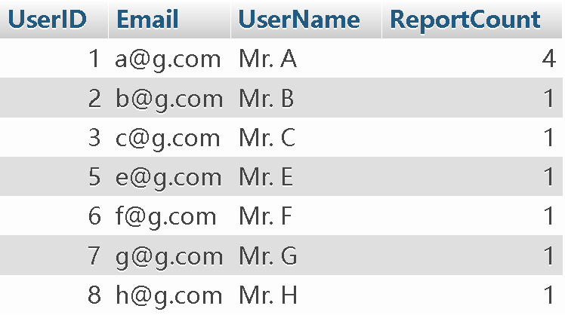

1. Which user receives the most notification for users? How about other users?

SELECT a.UserID, a.Email, a.UserName, COUNT(*) AS NotificationCount

FROM MAPUSER a

JOIN NOTIFICATIONFORUSER b ON a.UserID = b.UserID

GROUP BY a.UserID

ORDER BY NotificationCount DESC;

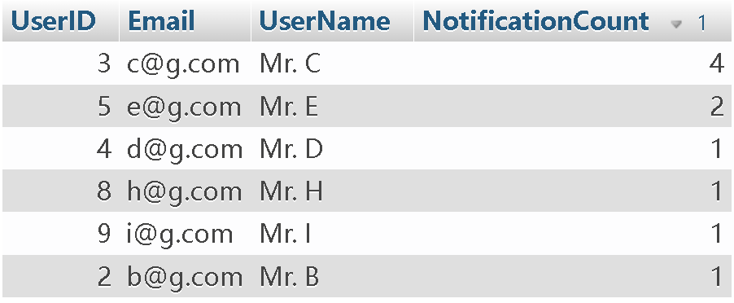

1. Which user has never submitted any report?

SELECT a.UserID, a.Email, a.UserName

FROM MAPUSER a

LEFT JOIN REPORT b ON a.UserID = b.UserID

WHERE b.ReportID IS NULL;

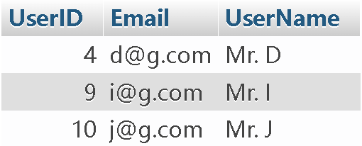

1. How many incidents happened on different roads?

SELECT a.RoadName, COUNT(b.IncidentID) as IncidentCount

FROM Incident b

INNER JOIN Road a ON b.RoadID = a.RoadID

GROUP BY a.RoadName

ORDER BY IncidentCount DESC;

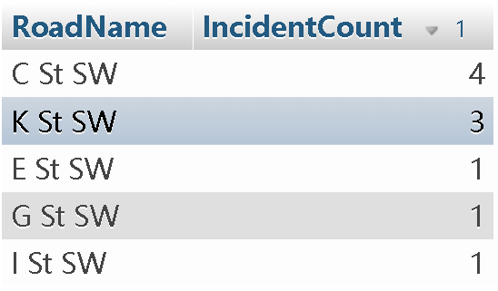

1. Following question 4, which road did most ‘Accident’ type of incidents happen?

SELECT a.RoadName, COUNT(*) AS NumAccidents

FROM INCIDENT b

JOIN ROAD a ON b.RoadID = a.RoadID

WHERE b.IncidentType = 'Accident'

GROUP BY a.RoadName

ORDER BY NumAccidents DESC;



1. Following question 5, which type of incident happens most frequently?

SELECT IncidentType, COUNT(*) AS Frequency

FROM INCIDENT

GROUP BY IncidentType

ORDER BY Frequency DESC;

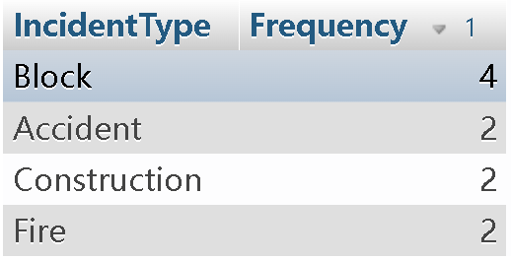

1. As a user, my ID is 1, how about my previous ‘Confirmed’ reports?

SELECT a.ReportID, a.Timestamp, a.Description, a.ReportStatus

FROM REPORT a

INNER JOIN CONFIRMATION b ON a.ConfirmationID = b.ConfirmationID

WHERE a.UserID = 1

AND a.ReportStatus = 'Confirmed'

ORDER BY a.Timestamp DESC;



1. Which roads have speed limits between 30-70?

SELECT RoadName, SpeedLimit

FROM road

WHERE SpeedLimit >= 30

AND SpeedLimit <= 70

ORDER BY SpeedLimit;

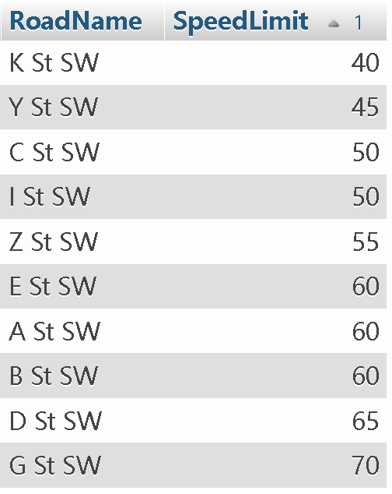

1. For example. if one accident happened on road ‘K St SW’, the owner of this road will suffer 1000 dollar damage, how may damage will he/she suffer?

SELECT 1000 * COUNT(*) AS TotalDamage

FROM INCIDENT a

JOIN ROAD b ON a.RoadID = b.RoadID

WHERE b.RoadName = 'K St SW';

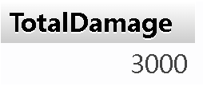

## References

Apple Inc. (n.d.). App Store. Retrieved March 2, 2023, from<https://www.apple.com/app-store/>.

Google. (n.d.). Google. Retrieved March 2, 2023, from: <https://www.google.com/>.